## **Task23- MYSQL**

**Task Description:**

**Create a Table Empl to store employee details as shown below and write statement for following queries based on table.**

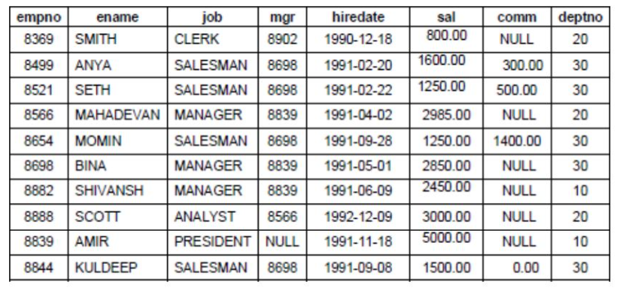

The table has been created as follows :

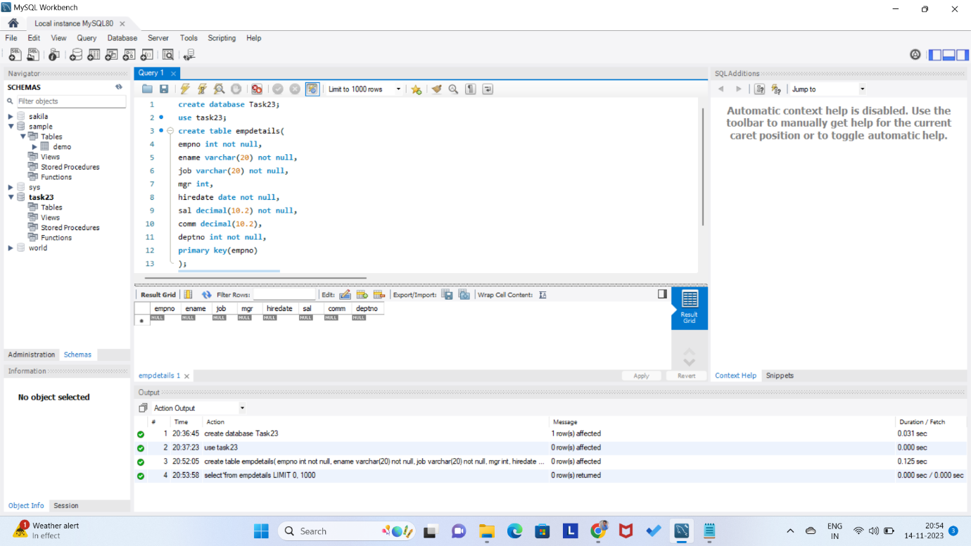

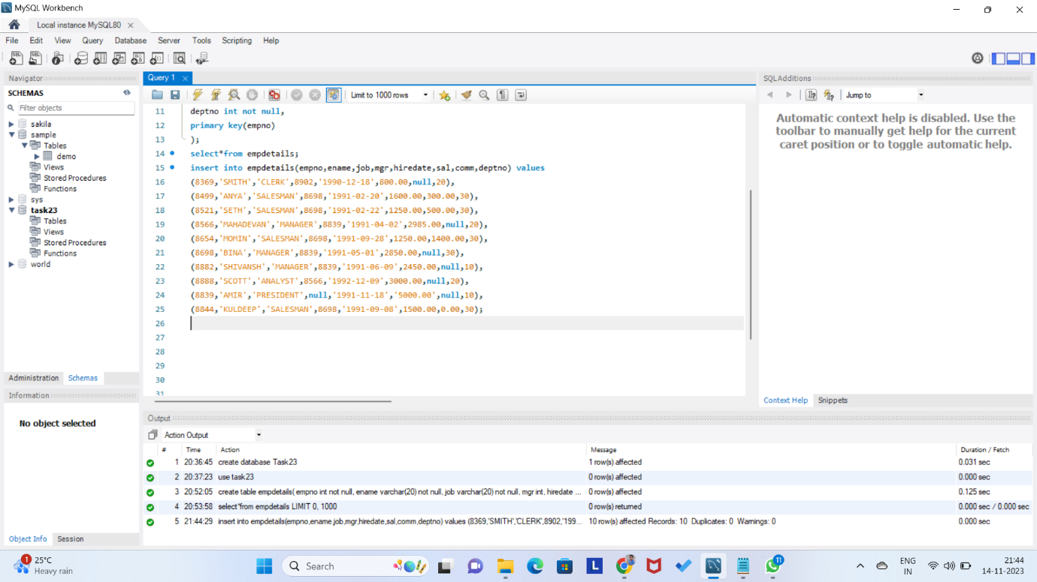

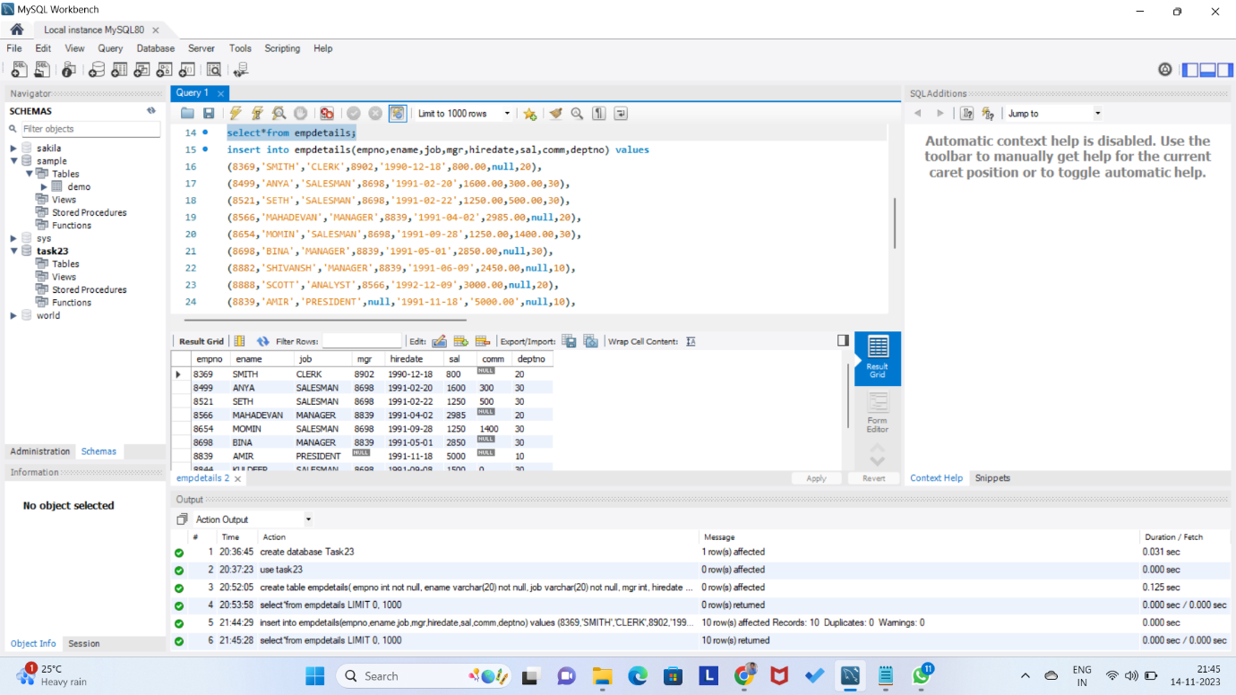

1.) Consider the Employee table and write SQL command to get the following.

A. Write a query to display EName and Sal of employees whose salary are greater than or equal to 2200?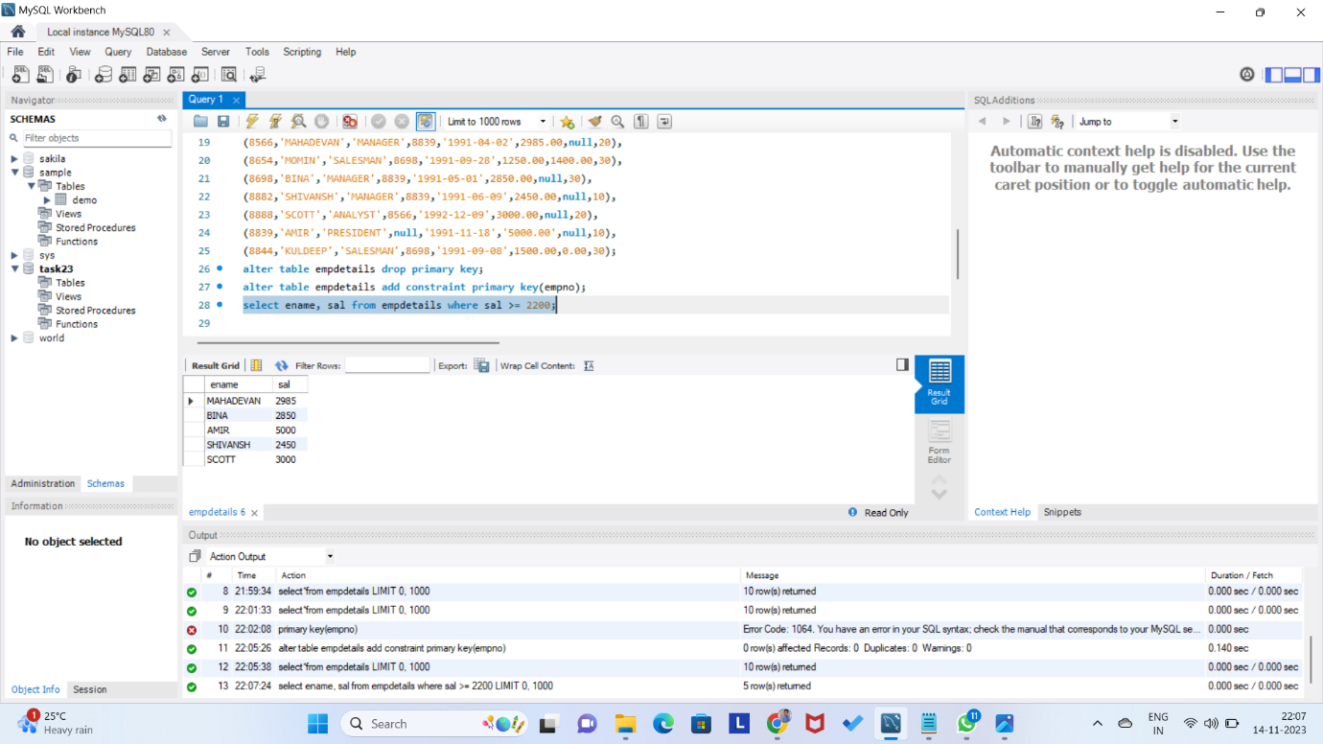

B. Write a query to display details of employees who are not getting commission?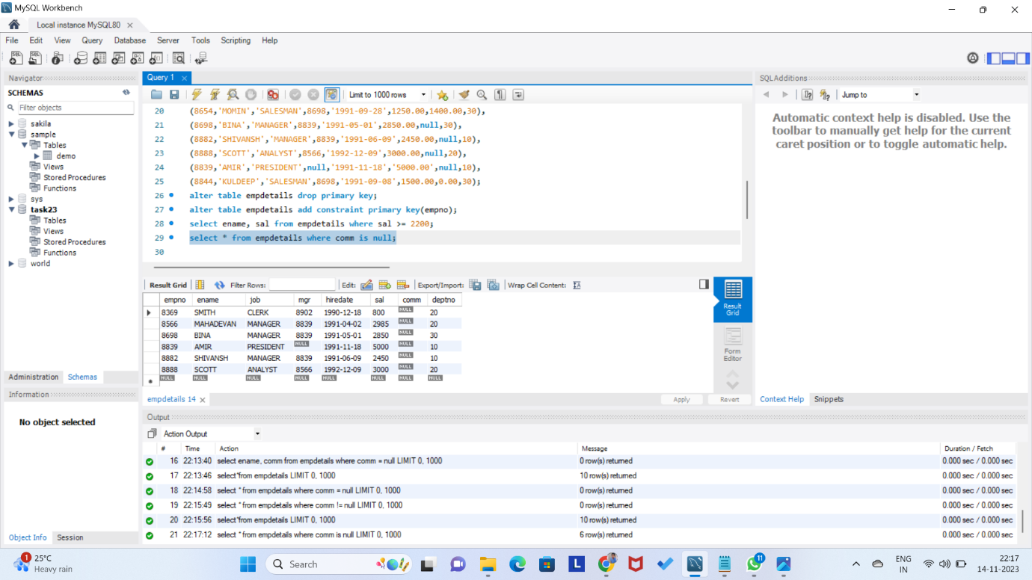

C. Write a query to display employee name and salary of those employees who don't have their salary in the range of 2500 to 4000?

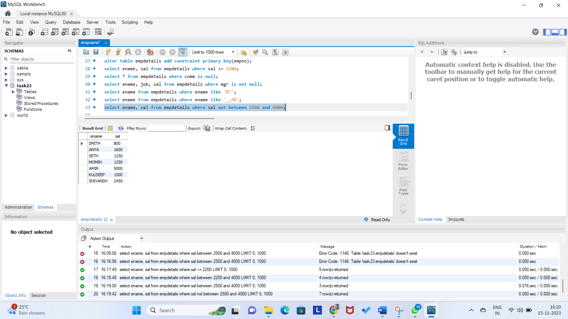

D. Write a query to display the name, job title and salary of employees who don't have a manager?

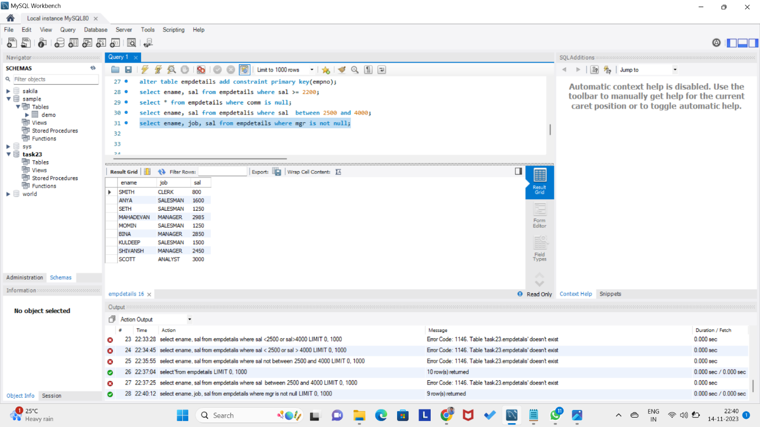

E. Write a query to display the name of an employee whose name contains "A" as third alphabet?

* There is no name of an employee whose name contains “A” as third alphabet

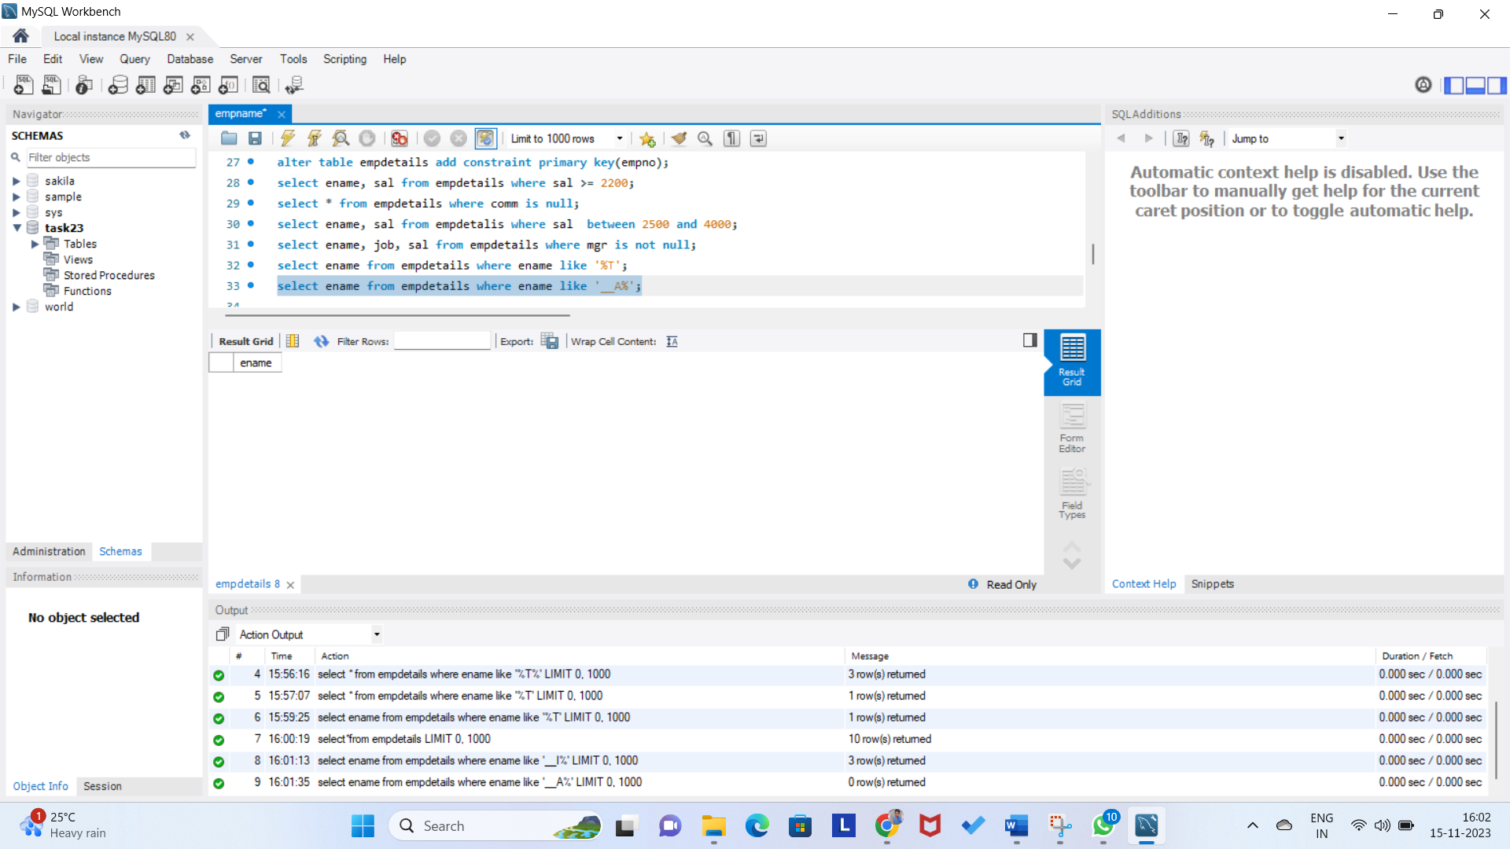

F. Write a query to display the name of an employee whose name contains "T" as the last alphabet?

